Purpose

Background Information:
EBS (Elastic Block Store) is a storage service for EC2 instances. EBS provides persistent storage, if you stop the EC2 instance the data stays, if you restart an EC2 instance the data stays. Basically it’s a way to keep data between instance start and stops. One of EBS’s most important features is snapshots which is a backup of an EBS volume stored in Amazon Simple Storage Service. EBS are mainly used on OS disks, databases running on EC2, app storage, and boot volumes.
EBS was created pretty early on (2008) due to the huge limitation of EC2 instances because their storage was temporary. After EBS launched, EC2’s was much more practical for business and AWS later on added snapshots, improving backup and recovery capabilities. As time went on AWS made small improvements like new volume types allowing customers to choose storage based on performance and cost needs.
A database server is a physical or virtual computer that runs a database software to store data so other applications can access it. Things it typically stores are user accounts, product inventories, orders, messages, grades, financial records, etc. And some popular database software includes MySQL, PostgreSQL, Microsoft SQL Server, and MongoDB.
Early computers stored data in paper records, punch cards, and flat files back in the 1950s-1960s, but the issue was that data was duplicated in many places, searching was slow, and updating records was difficult. To fix this, organizations started creating database management systems in the 1960s. These worked but were complicated and inflexible. In the 2000-210s companies started to handle enormous amounts of data which lead to cloud databases where cloud providers managing database servers for customers.
Scaling is adjusting the amount of computing resources based on demand, for example during a sale the company may need to accommodate for extra customers on their site. Load balancing is distributing workload across multiple servers. Without load balancing a single device may get overworked.
Before scaling and load balancing in the 1960s-1980s early computer systems usually ran on a single large mainframe. When more performance was needed, companies would either buy a bigger computer, add more memory, or upgrade CPUs. This is what we now call vertical scaling. The problem with this is that it’s really expensive; there's a limited maximum size; and a single point of failure. In the 1980s-1990s, networks grew a lot and companies started running multiple servers. Some hardware companies like Cisco and F5 started creating dedicated load-balancing appliances. Some benefits of this were better performance, higher availability, and fault tolerance. In the late 1990s-2000s, websites became more popular and companies like google, amazon, and yahoo!, needed thousands of servers. In 2006, AWS launched EC2 making scaling much easier. Instead of purchasing hardware, customers could launch new servers in minutes. The challenge became how do we automatically add and remove servers as traffic changes? To fix this AWS introduced Elastic Load Balancing in 2009. It automatically distributed incoming traffic, checked server health, and routed around failures. Customers no longer needed expensive physical load balancers. In 2010 AWS introduced Amazon EC2 Auto Scaling. Now AWS could launch new EC2 instances when traffic increased and remove instances when traffic decreased. This saved money because customers paid only for what they needed.

Lab Summary:

Lab 4: Working with EBS
Task 1: Create an EBS Volume
- Open EC2 from the AWS Management Console.
- Select Instances and locate the Lab instance.
- Note the instance's Availability Zone (for example, us-east-1a).
- In the left navigation pane, choose Volumes.
- Select Create volume and configure:
  - Volume type: General Purpose SSD (gp2)
  - Size: 1 GiB
  - Availability Zone: Same AZ as the Lab instance
- Add a tag:
  - Key: Name
  - Value: My Volume
- Choose Create volume.
- Wait for the volume state to change from Creating to Available.

Task 2: Attach the Volume to the EC2 Instance
- Select My Volume.
- Choose Actions → Attach volume.
- Configure:
  - Instance: Lab
  - Device name: /dev/sdb
- Choose Attach volume.
- Verify that the volume state changes to In-use.

Task 3: Connect to the EC2 Instance
- Return to Instances and select the Lab instance.
- Choose Connect.
- Open the Session Manager tab and select Connect.
- In the terminal, switch to the ec2-user account:
sudo su -l ec2-user

Task 4: Create and Configure a File System
Check Existing Storage
- Display current storage devices:
df -h
Only the original 8 GiB root volume should appear.
Format the New Volume
- Create an ext3 file system on the new volume:
sudo mkfs -t ext3 /dev/sdb
Create a Mount Point
- Create a directory for the new volume:
sudo mkdir /mnt/data-store
Mount the Volume
- Mount the volume:
sudo mount /dev/sdb /mnt/data-store
Configure Automatic Mounting
- Add the volume to /etc/fstab:
echo "/dev/sdb /mnt/data-store ext3 defaults,noatime 1 2" | sudo tee -a /etc/fstab
- Verify the configuration:
cat /etc/fstab
Verify Storage
- Check storage again:
df -h
You should now see /dev/xvdb mounted at /mnt/data-store.
Create and Verify a Test File
- Create a text file on the volume:
sudo sh -c "echo some text has been written > /mnt/data-store/file.txt"
- Confirm the file contents:
cat /mnt/data-store/file.txt

Task 5: Create an EBS Snapshot
- In the EC2 Console, select Volumes and choose My Volume.
- Select Actions → Create snapshot.
- Add a tag:
  - Key: Name
  - Value: My Snapshot
- Choose Create snapshot.
- Open Snapshots from the navigation pane.
- Wait for the snapshot status to change from Pending to Completed.
Remove the Test File
- In the terminal, delete the file:
sudo rm /mnt/data-store/file.txt
- Verify the file has been removed:
ls /mnt/data-store/

Task 6: Restore the Snapshot
Create a Volume from the Snapshot
- Select My Snapshot.
- Choose Actions → Create volume from snapshot.
- Configure:
  - Availability Zone: Same AZ used previously
- Add a tag:
  - Key: Name
  - Value: Restored Volume
- Choose Create volume.
Attach the Restored Volume
- Open Volumes and select Restored Volume.
- Choose Actions → Attach volume.
- Configure:
  - Instance: Lab
  - Device name: /dev/sdc
- Choose Attach volume.
- Verify the volume state changes to In-use.
Mount the Restored Volume
- Create a mount directory:
sudo mkdir /mnt/data-store2
- Mount the restored volume:
sudo mount /dev/sdc /mnt/data-store2
Verify the Restored Data
- List the contents of the restored volume:
ls /mnt/data-store2/
- Confirm that file.txt is present.
This demonstrates that the EBS snapshot successfully preserved the data and restored it to a new volume.

Lab 5: Build a Database Server
Task 1: Create a Security Group for the Database
- Open VPC from the AWS Management Console.
- In the left navigation pane, select Security Groups.
- Choose Create security group and configure:
  - Security group name: DB Security Group
  - Description: Permit access from Web Security Group
  - VPC: Lab VPC
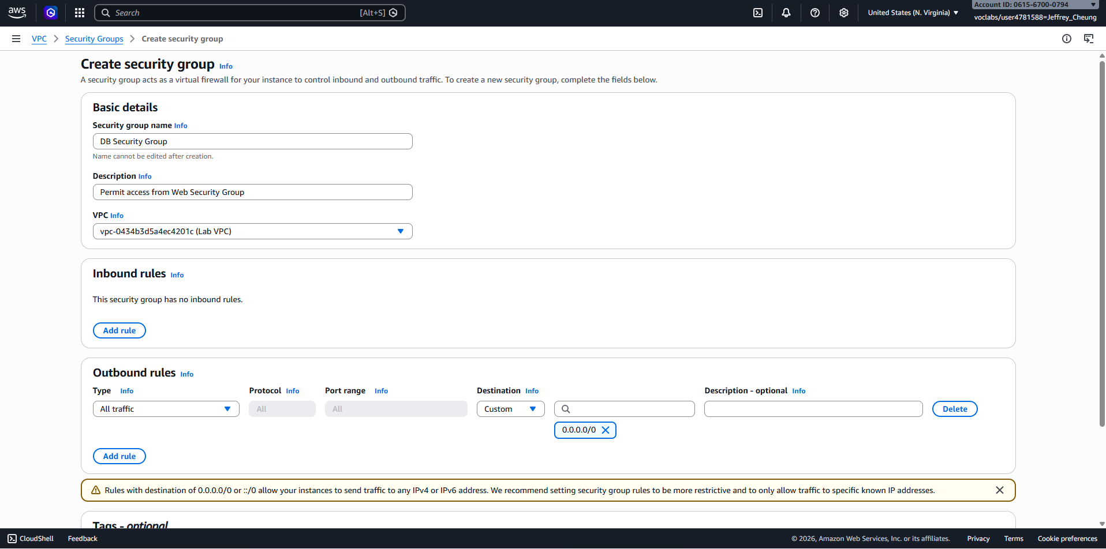
- Under Inbound rules, choose Add rule.
- Configure the rule:
  - Type: MySQL/Aurora (3306)
  - Source: Web Security Group
- Choose Create security group.
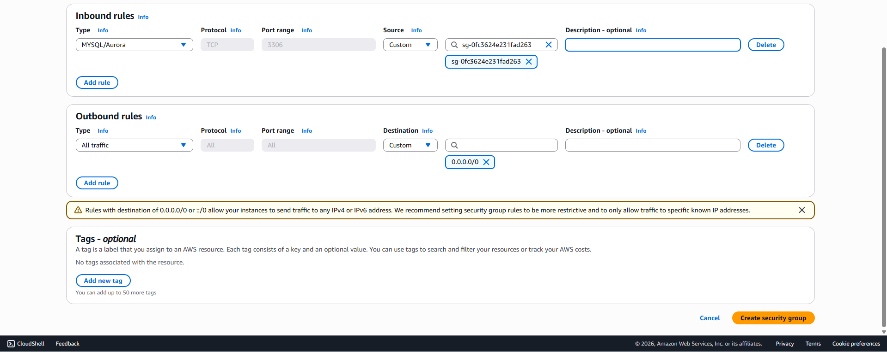
This security group allows EC2 instances associated with the Web Security Group to connect to the database on port 3306.

Task 2: Create a DB Subnet Group
- Open RDS from the AWS Management Console.
- In the left navigation pane, select Subnet groups.
- Choose Create DB subnet group.
- Configure:
  - Name: DB-Subnet-Group
  - Description: DB Subnet Group
  - VPC: Lab VPC
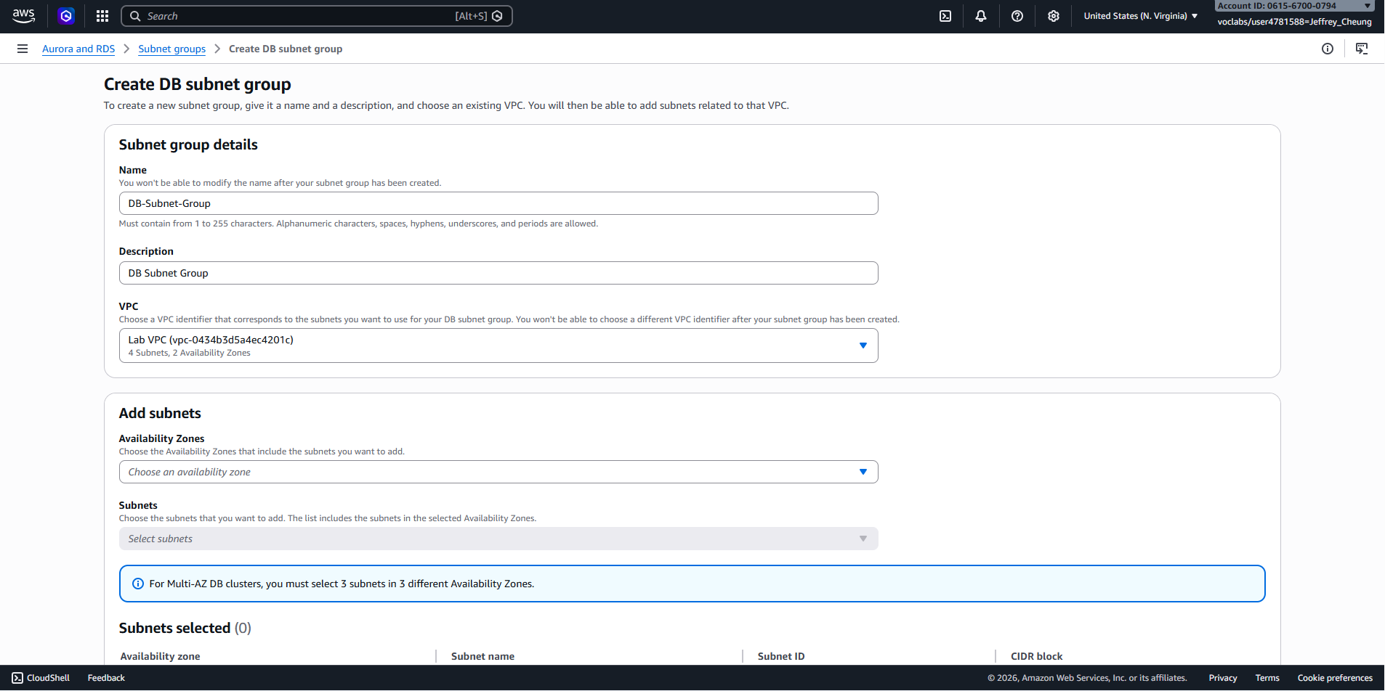
- Under Availability Zones, select:
  - us-east-1a
  - us-east-1b
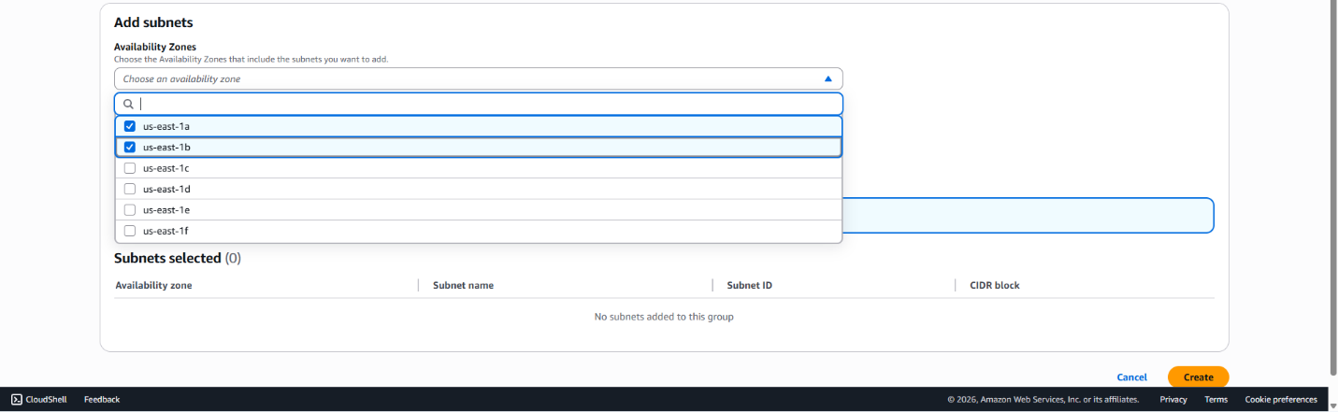
- Under Subnets, select the private subnets with CIDR ranges:
  - 10.0.1.0/24
  - 10.0.3.0/24
- Verify that both subnets appear in the selected subnet list.
- Choose Create.
The subnet group defines which subnets Amazon RDS can use when deploying the database.

Task 3: Create an Amazon RDS Database
- In the left navigation pane, select Databases.
- Choose Create database.
- Under Engine options, select:
  - MySQL
- Under Templates, choose:
  - Dev/Test
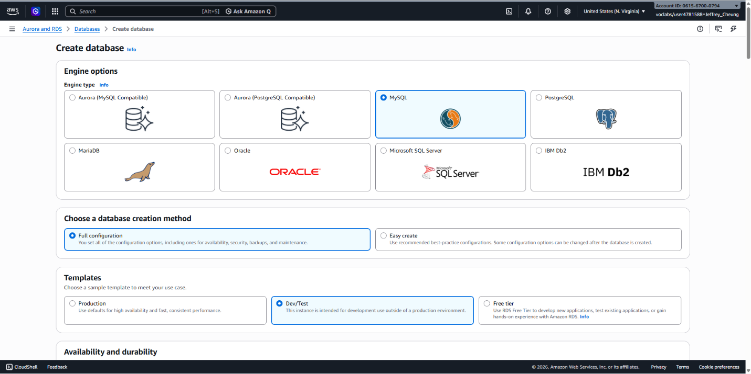
- Under Availability and durability, select:
  - Multi-AZ DB instance
Database Settings
- Configure:
  - DB instance identifier: lab-db
  - Master username: main
  - Master password: lab-password
  - Confirm password: lab-password
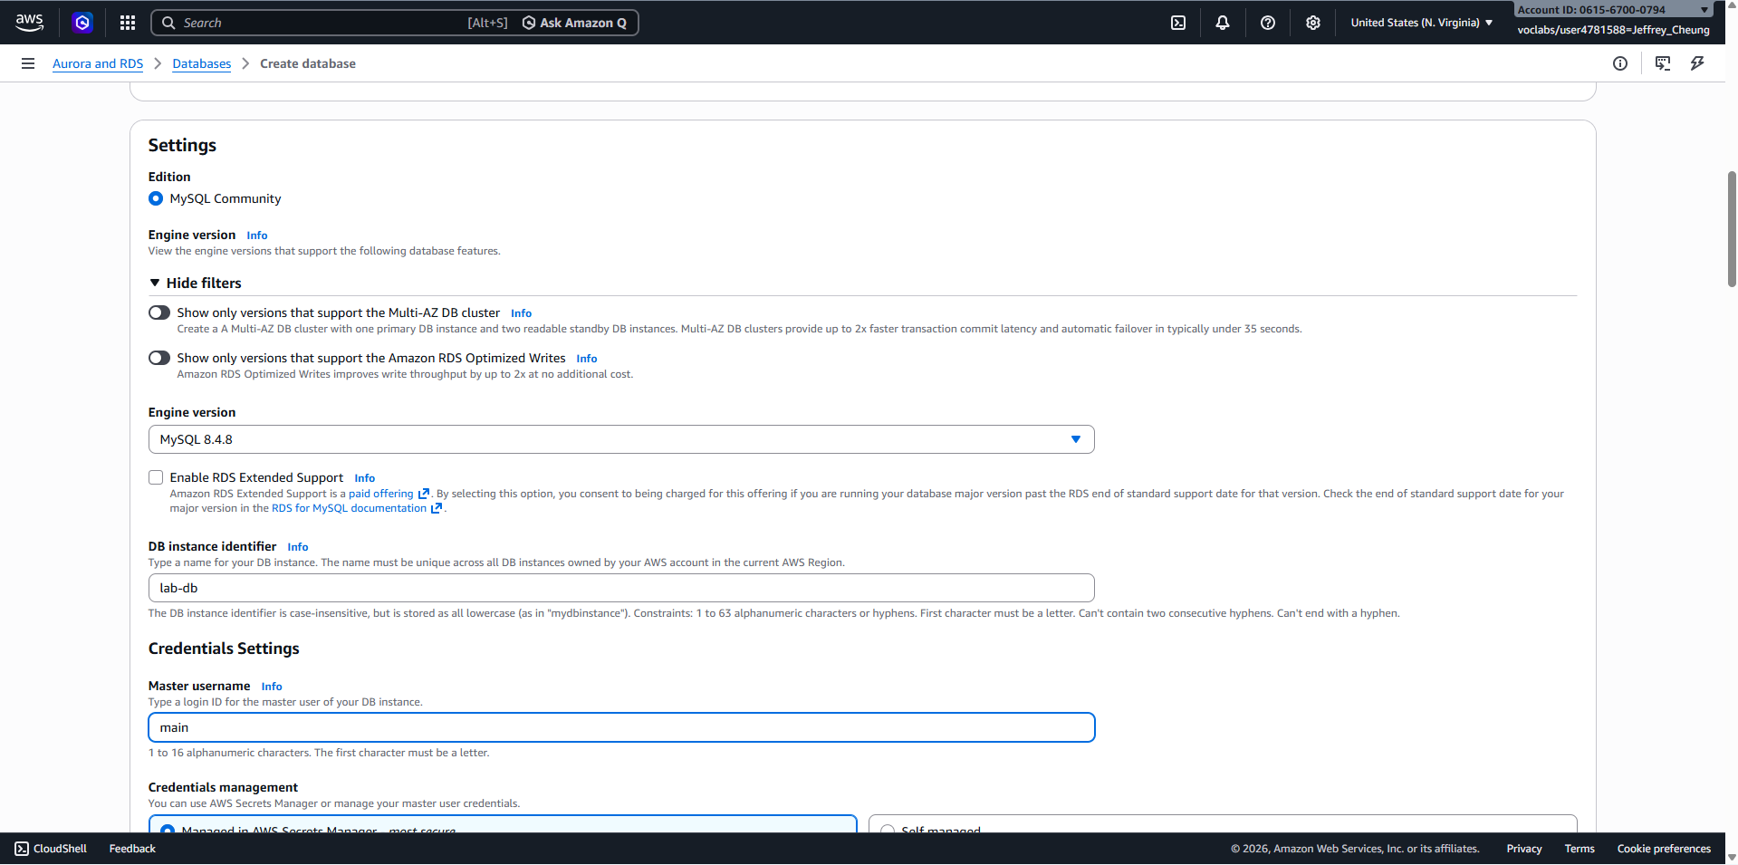
Instance Configuration
- Under DB instance class:
  - Select Burstable classes
  - Choose db.t3.micro
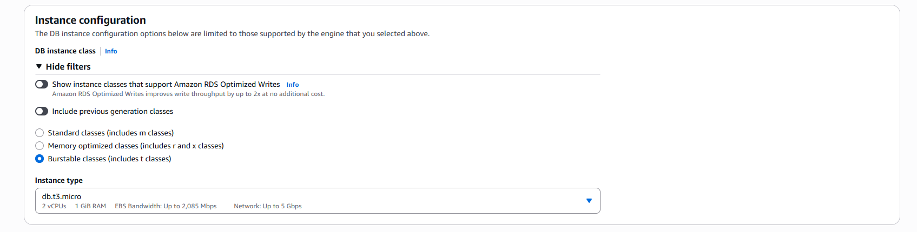
Storage Configuration
- Configure:
  - Storage type: General Purpose (SSD)
  - Allocated storage: 20 GiB
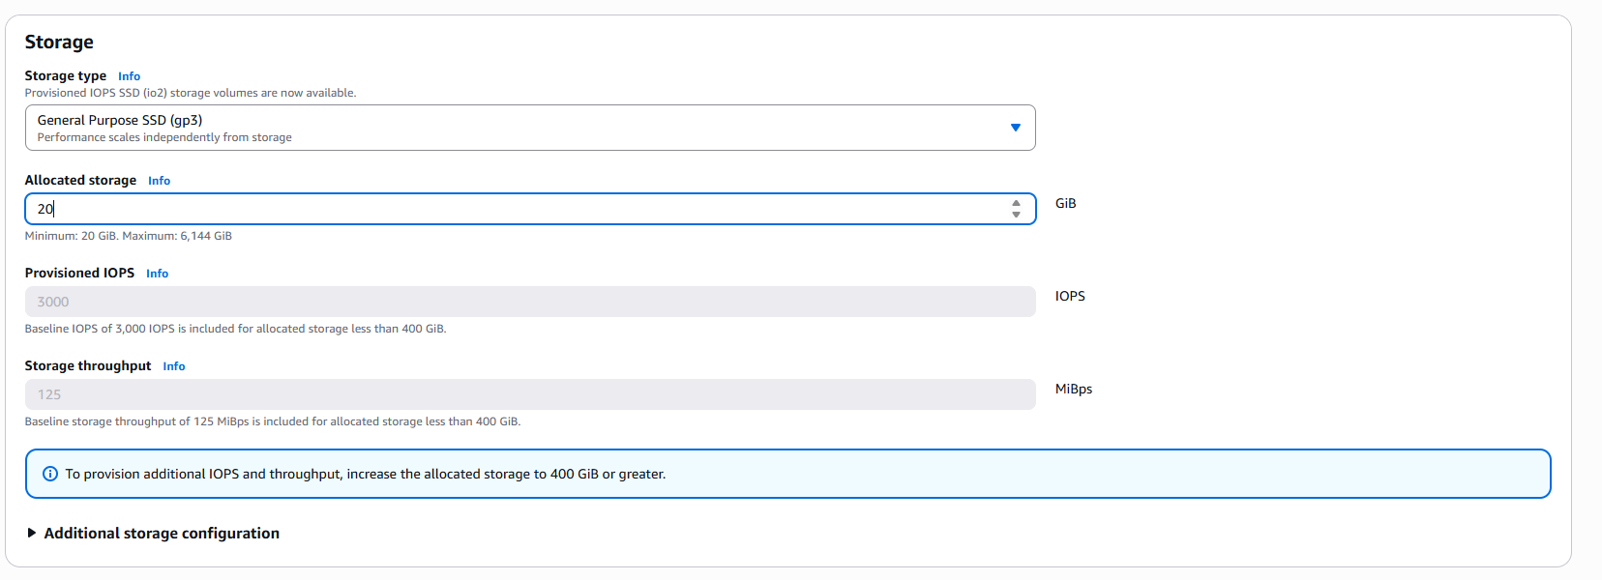
Connectivity
- Configure:
  - VPC: Lab VPC
  - Security group: DB Security Group
  - Remove the default security group if present
Additional Settings
- Expand Monitoring and disable:
  - Enable Enhanced Monitoring
- Under Additional configuration, configure:
  - Initial database name: lab
  - Disable Automatic backups
  - Disable Encryption
- Choose Create database.
Wait for Deployment
- Select the lab-db database.
- Wait until the database status changes to Modifying or Available.
- Deployment may take several minutes because a Multi-AZ configuration is being created.
- Open the Connectivity & Security section.
- Copy the database Endpoint and save it for later use.
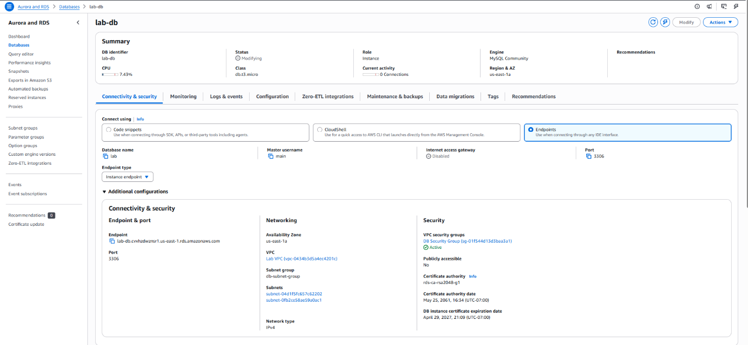
- Example: lab-db.xxxx.us-east-1.rds.amazonaws.com
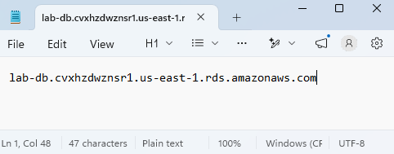

Task 4: Connect the Application to the Database
- Obtain the WebServer IP address from the AWS Details panel.
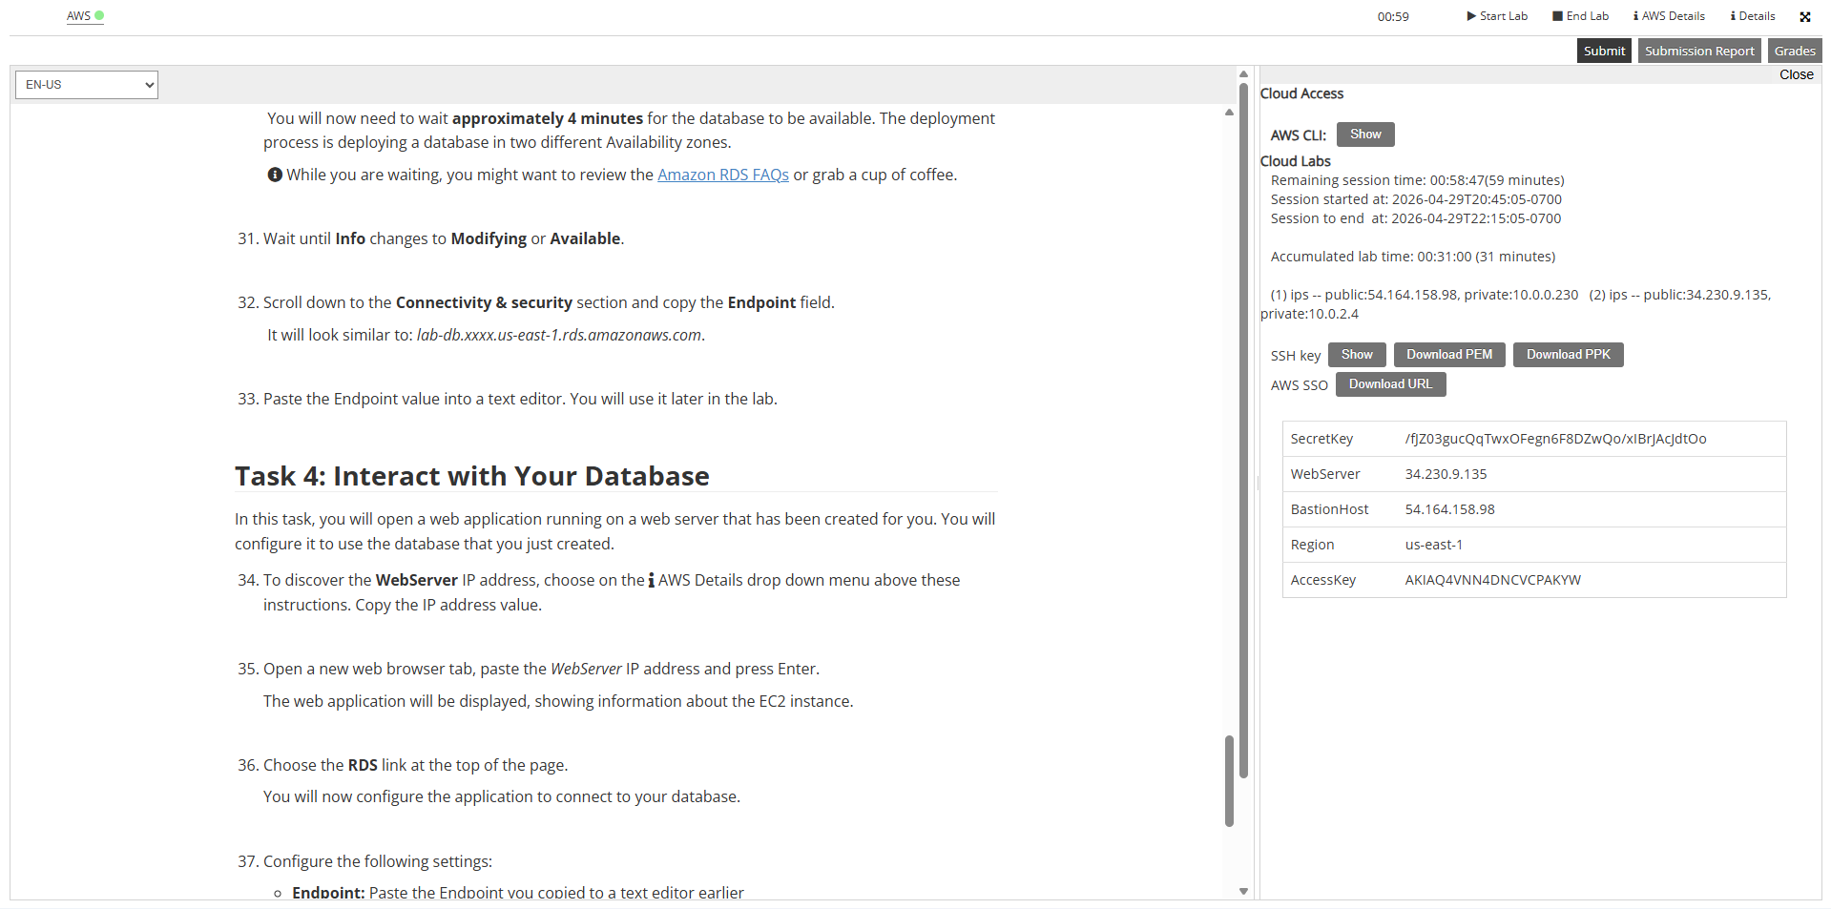
- Open a new browser tab and navigate to the WebServer IP address.
- Verify that the web application loads successfully.
- Select the RDS link at the top of the page.
Configure Database Access
- Enter the following information:
  - Endpoint: Database endpoint copied earlier
  - Database: lab
  - Username: main
  - Password: lab-password
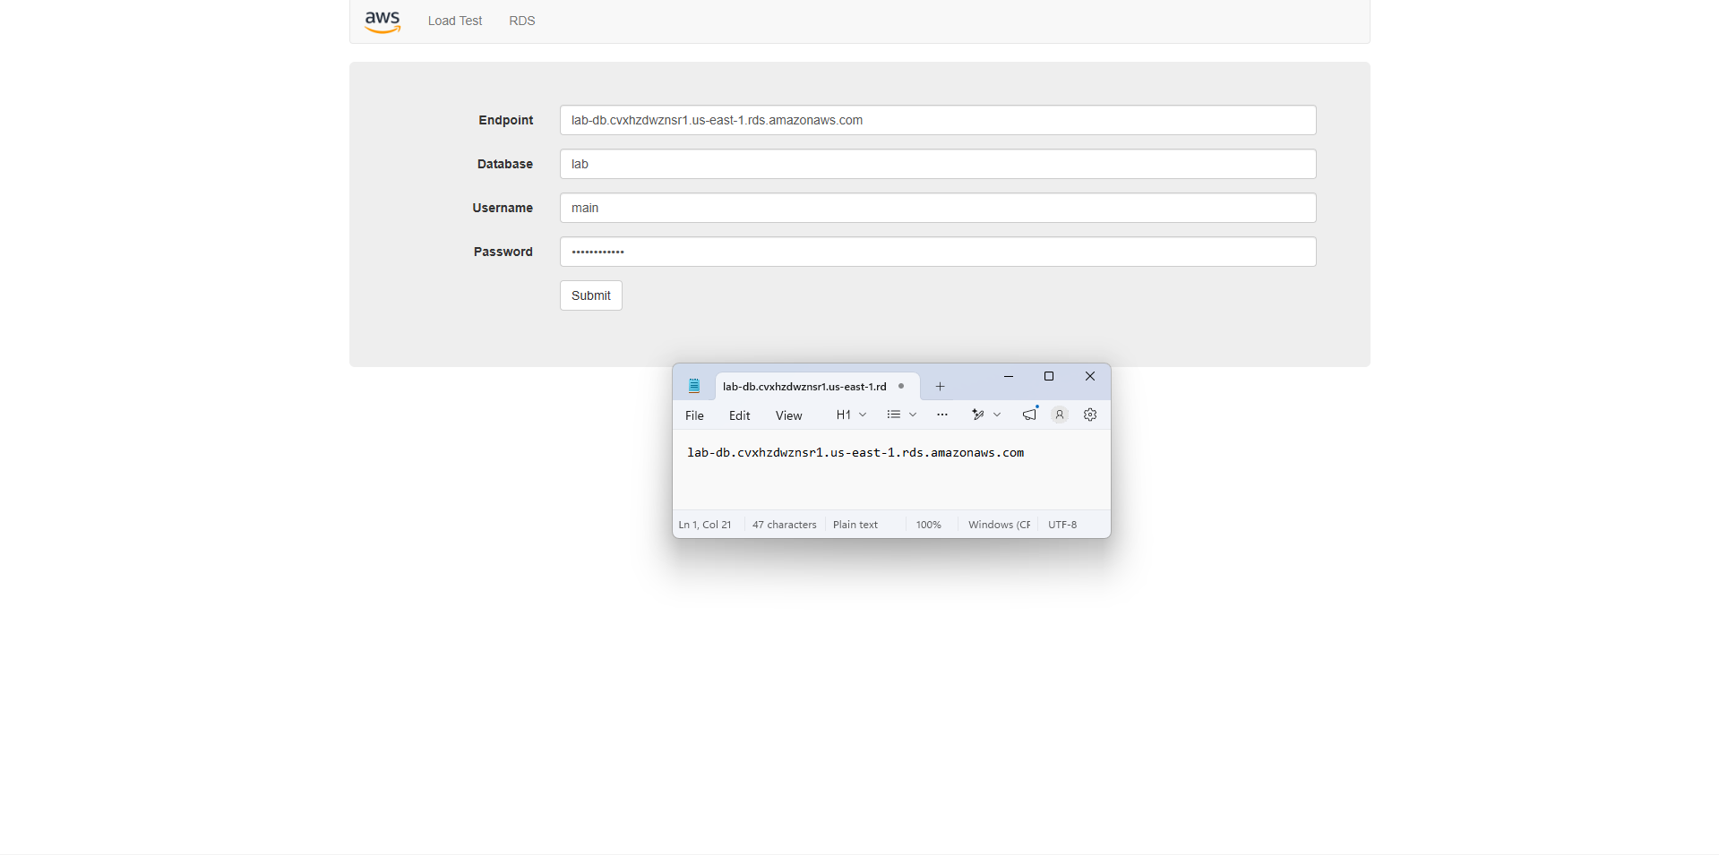
- Choose Submit.
- Wait for the application to initialize the database connection.
- Once complete, the Address Book application will appear.
Test Database Functionality
- Create a new contact.
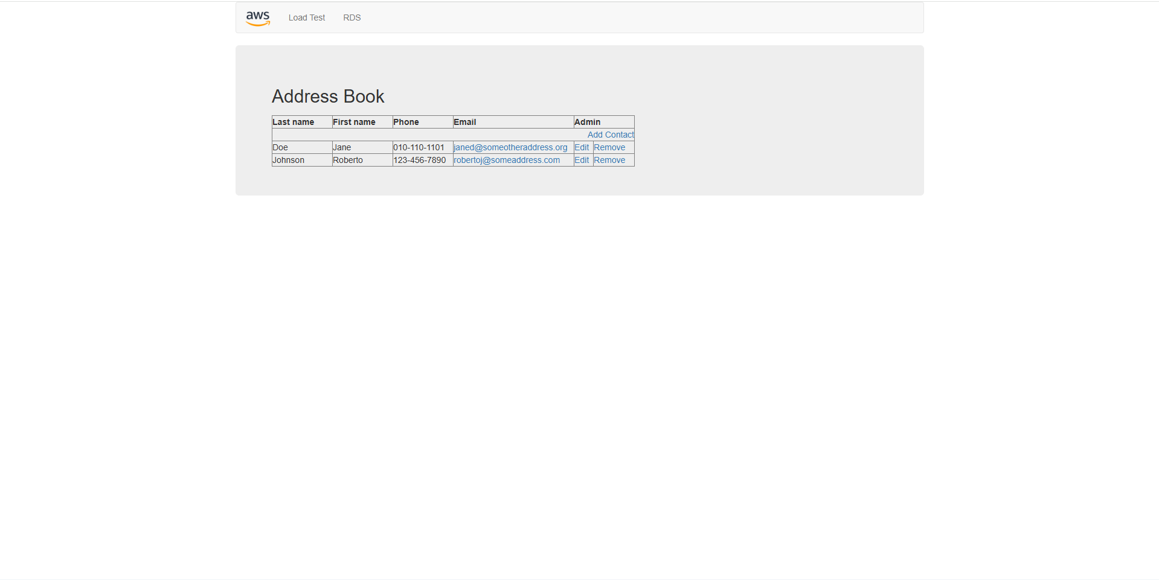
- Edit an existing contact.
- Delete a contact.
- Verify that all changes are saved successfully.
The application is now using the Amazon RDS database to store data, and the database is automatically replicated across multiple Availability Zones for improved availability and durability.

Lab 6: Scale and Load balance Your Architecture
Task 1: Create an AMI for Auto Scaling
- Open EC2 from the AWS Management Console.
- Select Instances and verify that Web Server 1 shows 2/2 Status Checks Passed.
- Select Web Server 1.
- Choose:
  - Actions → Image and templates → Create image
- Configure:
  - Image name: WebServerAMI
  - Image description: Lab AMI for Web Server
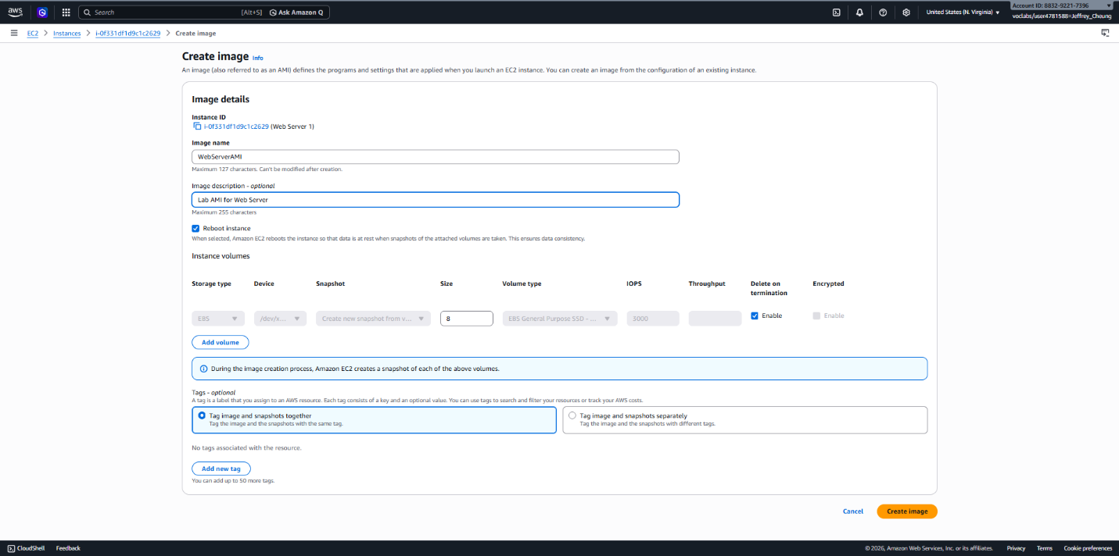
- Choose Create image.
- Record the AMI ID displayed in the confirmation message.
This AMI captures the current state of the web server and will be used to launch identical instances through Auto Scaling.

Task 2: Create a Target Group and Load Balancer
Create a Target Group
- In the EC2 console, select Target Groups.
- Choose Create target group.
- Configure:
  - Target type: Instances
  - Target group name: LabGroup
  - VPC: Lab VPC
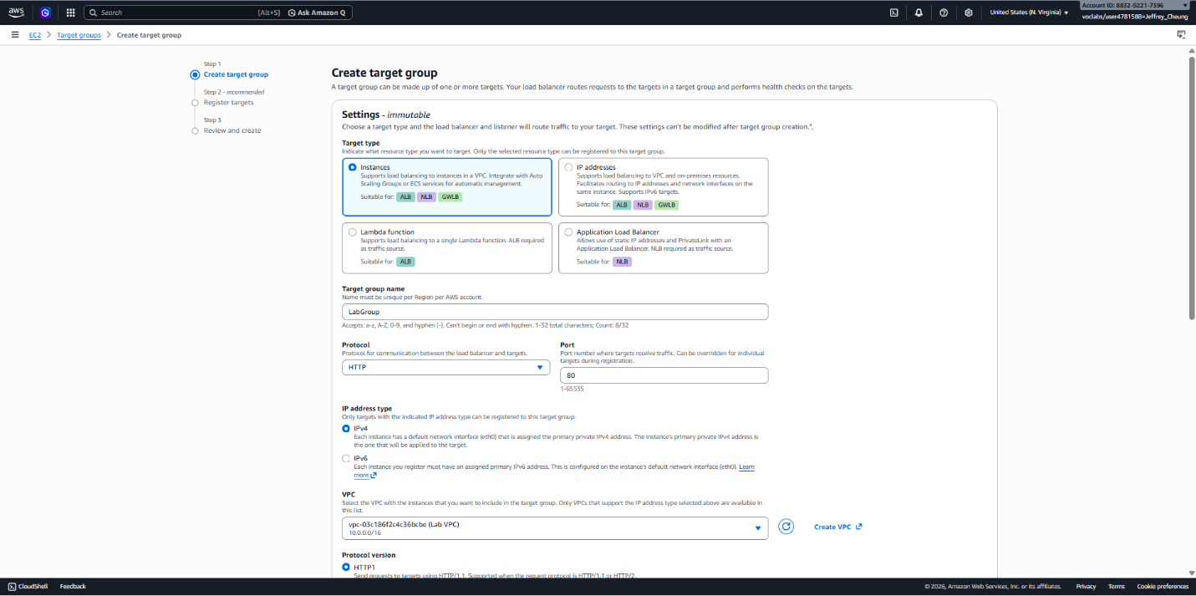
- Choose Next.
- Skip target registration since no Auto Scaling instances exist yet.
- Choose Create target group.
Create an Application Load Balancer
- Select Load Balancers.
- Choose Create load balancer.
- Under Application Load Balancer, select Create.
- Configure:
  - Load balancer name: LabELB
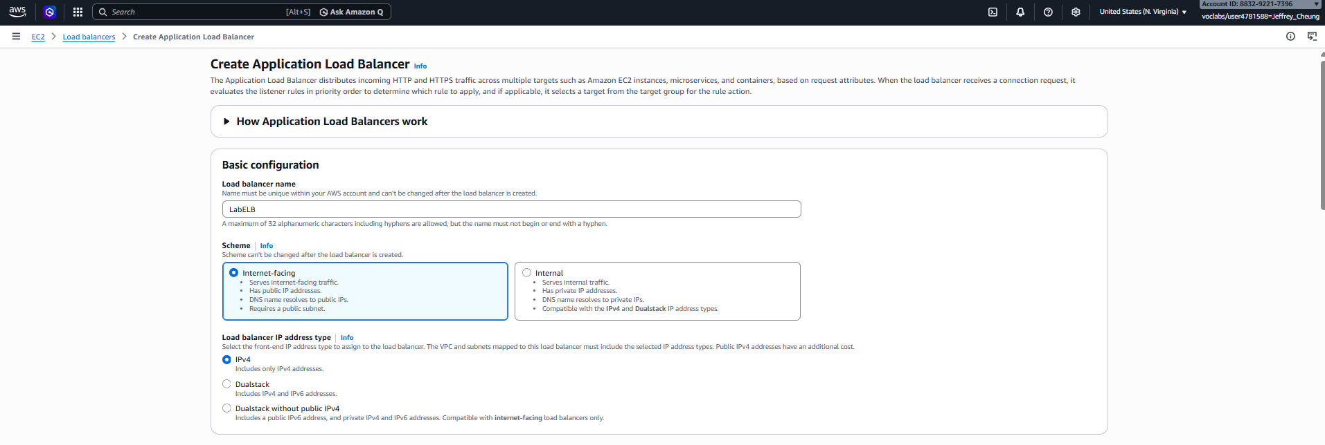
- Under Network mapping:
  - VPC: Lab VPC
  - Select Public Subnet 1 in the first Availability Zone
  - Select Public Subnet 2 in the second Availability Zone
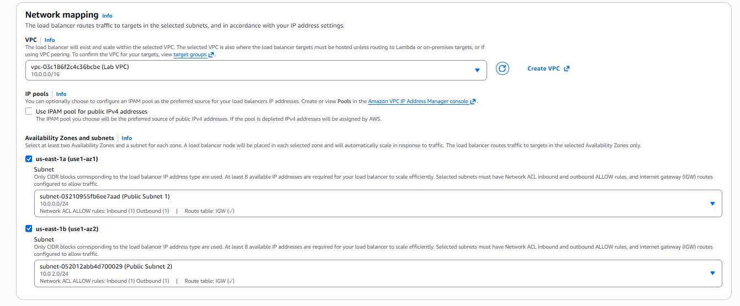
- Under Security Groups:
  - Select Web Security Group
  - Remove the default security group
- Configure the HTTP listener:
  - Default action: Forward to LabGroup
- Choose Create load balancer.
- Once creation is complete, select View load balancer.
The load balancer may still show a status of Provisioning, which is expected.

Task 3: Create a Launch Template and Auto Scaling Group
Create a Launch Template
- Select Launch Templates.
- Choose Create launch template.
- Configure:
  - Launch template name: LabConfig
  - Enable Auto Scaling guidance
- Under My AMIs, select:
  - AMI: WebServerAMI
- Configure:
  - Instance type: t2.micro
  - Key pair: vockey
- Under Security Groups:
  - Select Existing security group
  - Choose Web Security Group
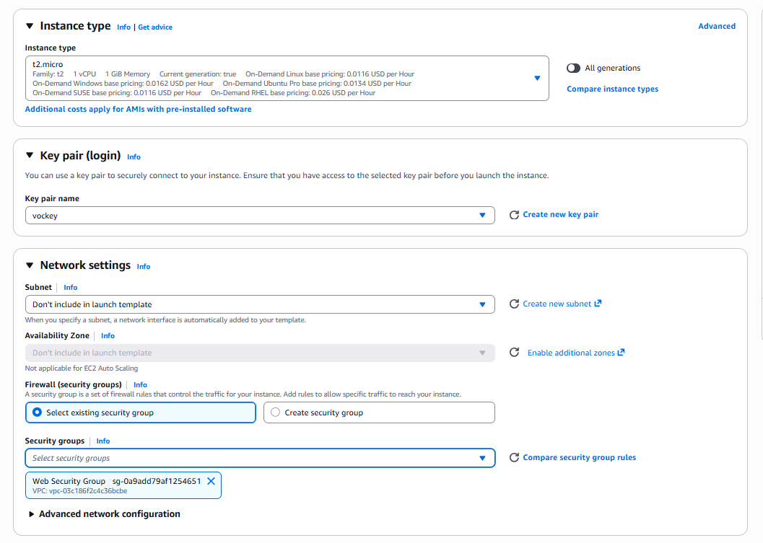
- Expand Advanced Details.
- Enable Detailed CloudWatch Monitoring.
- Choose Create launch template.
Create the Auto Scaling Group
- Open the newly created LabConfig template.
- Choose:
  - Actions → Create Auto Scaling Group
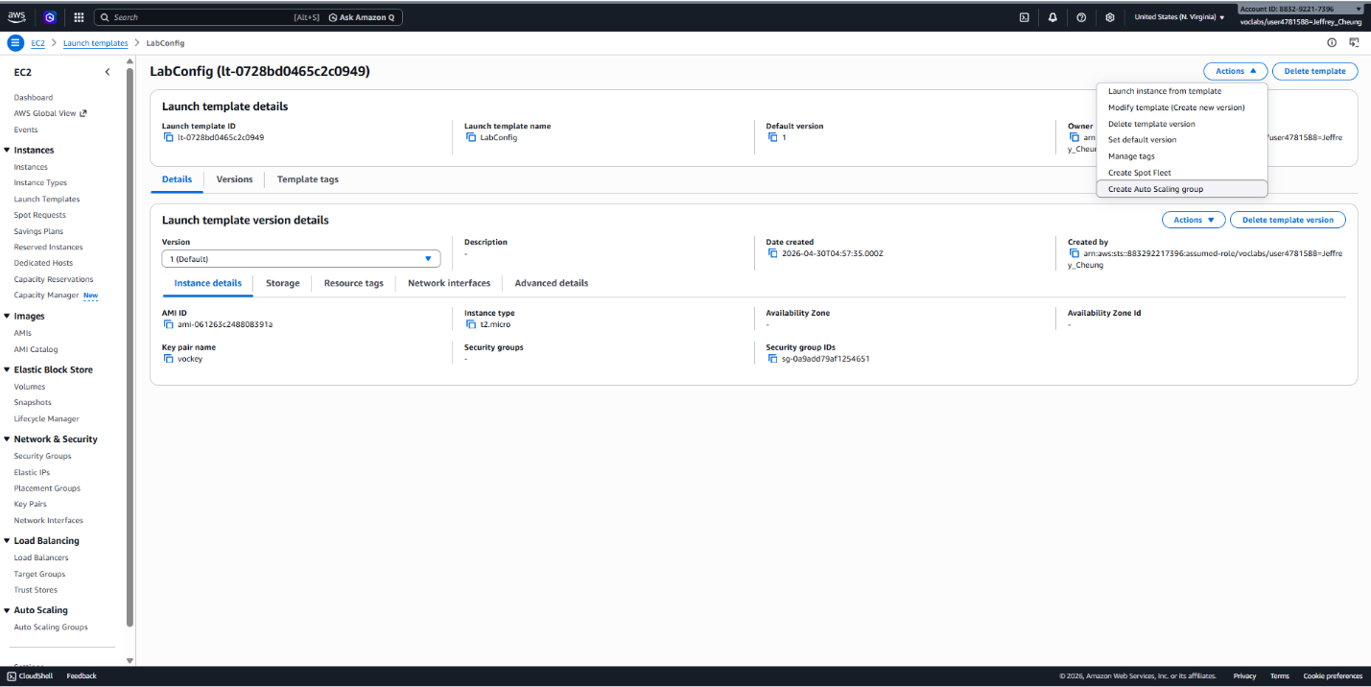
Step 1: Basic Configuration
- Configure:
  - Auto Scaling group name: Lab Auto Scaling Group
  - Launch template: LabConfig
- Choose Next.
Step 2: Networking
- Configure:
  - VPC: Lab VPC
  - Subnets: Private Subnet 1 and Private Subnet 2
- Choose Next.
Step 3: Load Balancing
- Select:
  - Attach to an existing load balancer
  - Target group: LabGroup
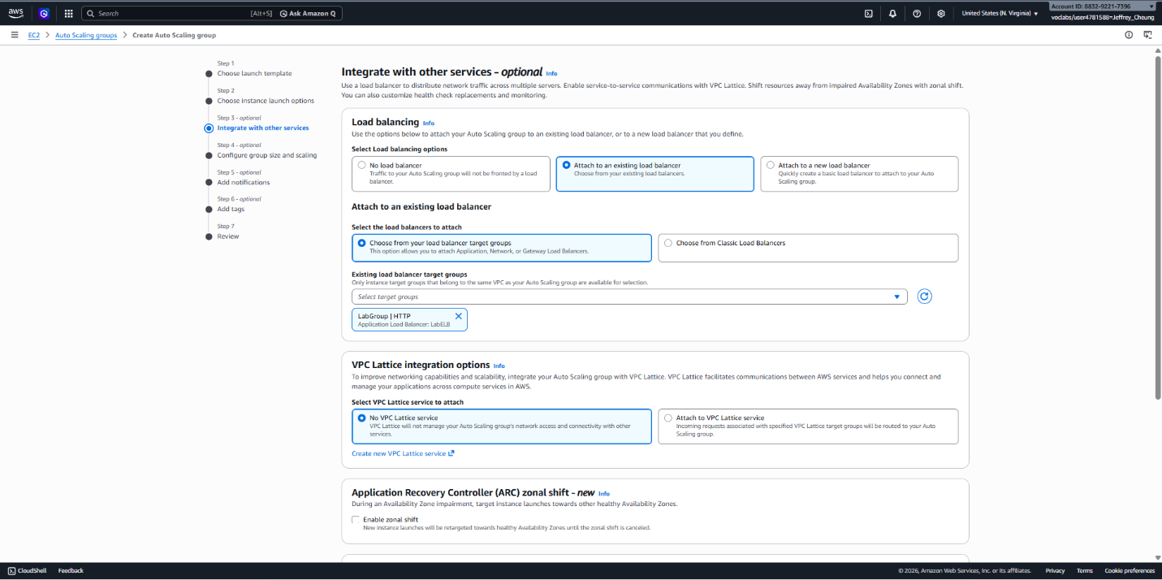
- Enable:
  - Group metrics collection within CloudWatch
- Choose Next.
Step 4: Scaling Configuration
- Configure:
  - Desired capacity: 2
  - Minimum capacity: 2
  - Maximum capacity: 6
- Configure the scaling policy:
  - Policy type: Target Tracking
  - Policy name: LabScalingPolicy
  - Metric: Average CPU Utilization
  - Target value: 60%
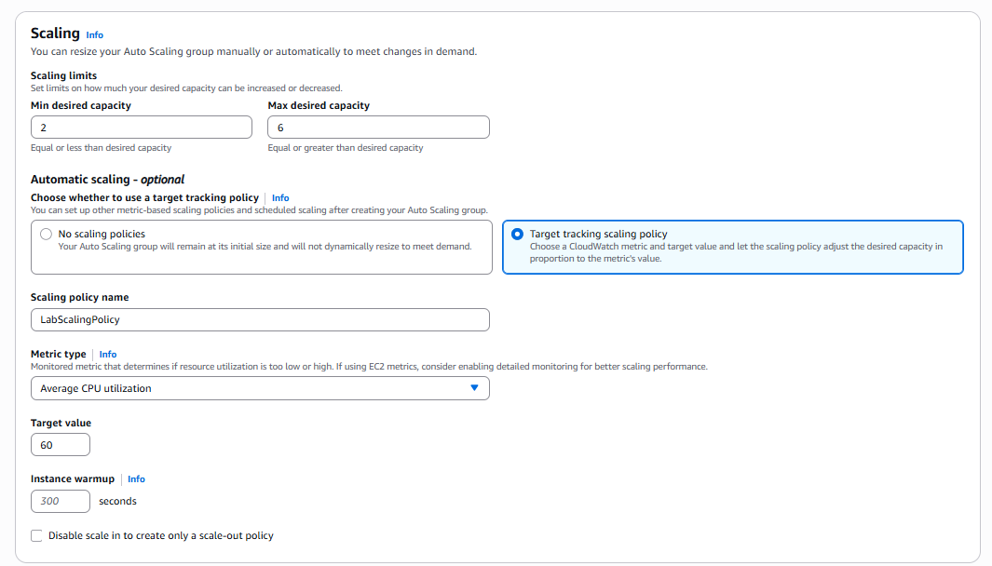
- Choose Next.
Step 5: Notifications
- Leave the default settings and choose Next.
Step 6: Tags
- Add a tag:
  - Key: Name
  - Value: Lab Instance
- Choose Next.
- Review the configuration and choose Create Auto Scaling Group.
The group will automatically launch two instances to meet the desired capacity.

Task 4: Verify Load Balancing
- Open Instances.
- Confirm that two instances named Lab Instance have been launched.
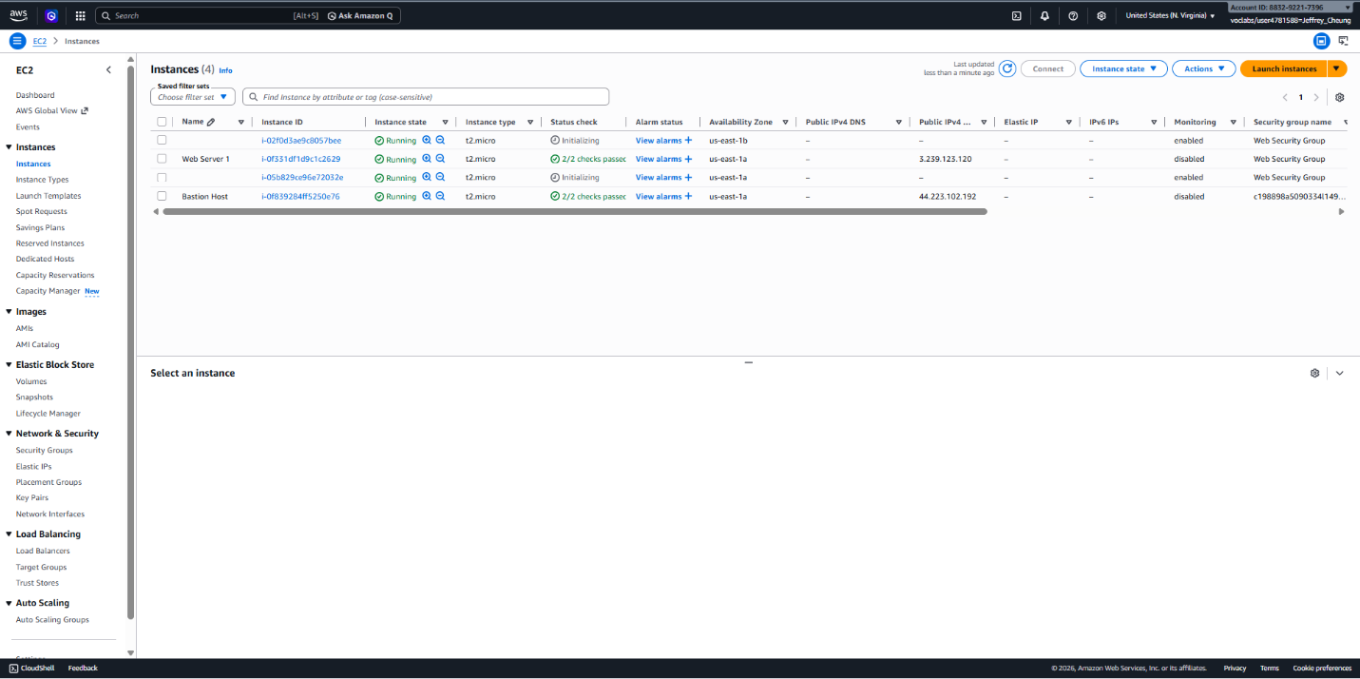
- Select Target Groups and open LabGroup.
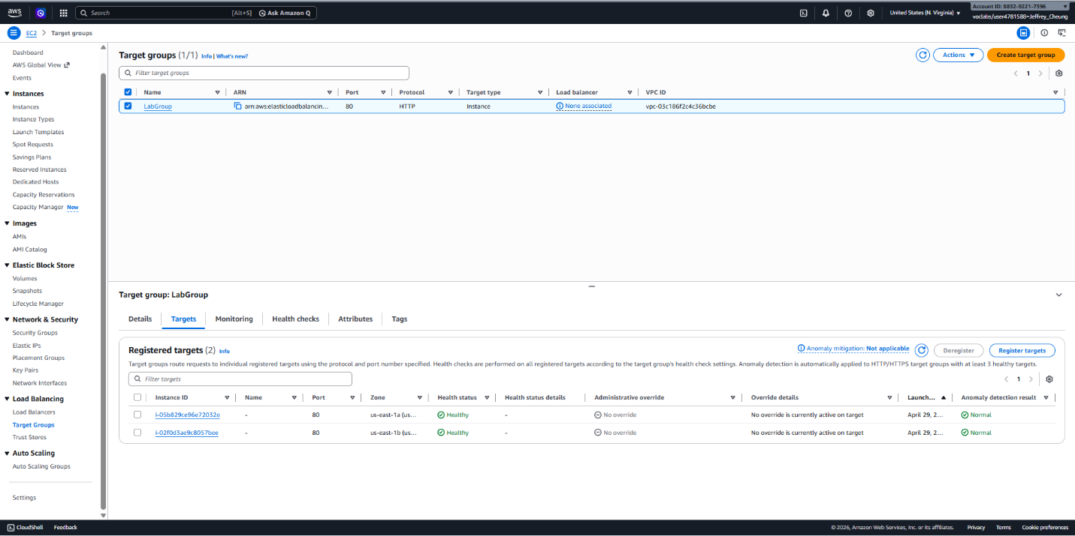
- Open the Targets tab.
- Wait until both instances display a status of Healthy.
Healthy targets have passed the load balancer health checks and are eligible to receive traffic.
- Select Load Balancers.
- Open LabELB.
- Copy the load balancer DNS Name.
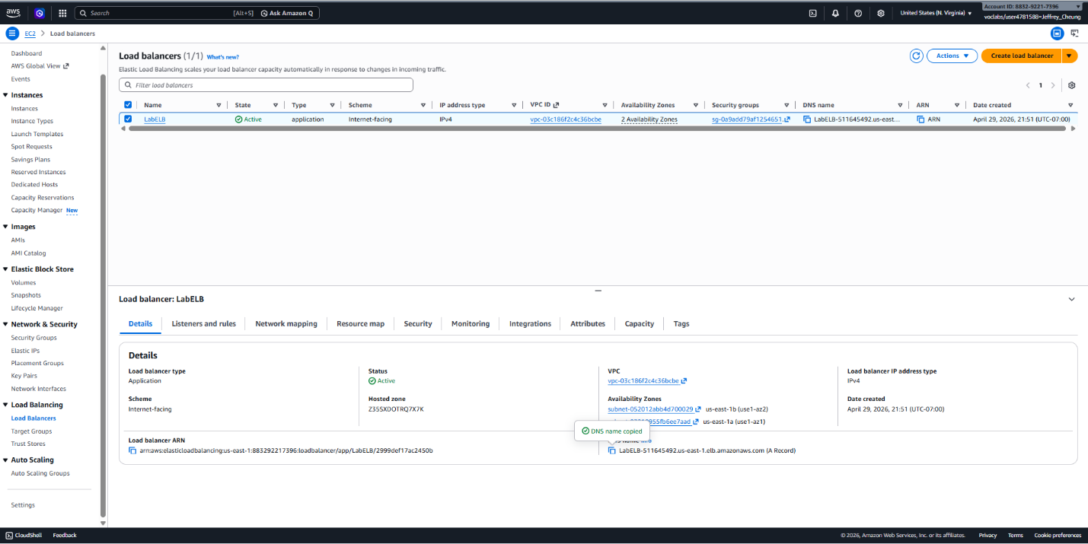
- Paste the DNS name into a web browser.
- Verify that the application loads successfully.
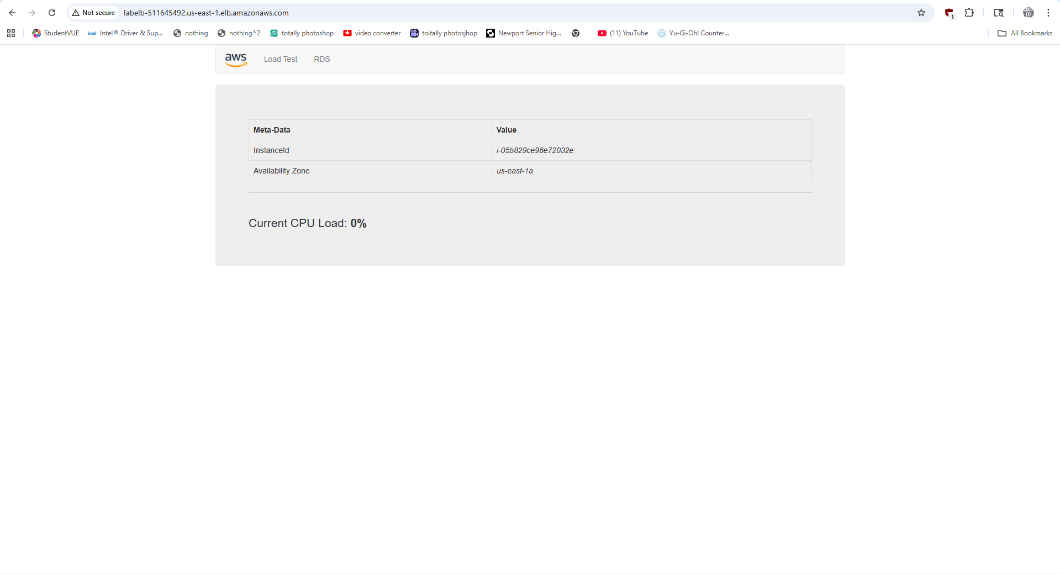
This confirms that traffic is being routed through the load balancer to the Auto Scaling instances.

Task 5: Test Auto Scaling
Review Scaling Alarms
- Open CloudWatch.
- Select All Alarms.
- Locate the two alarms automatically created by the Auto Scaling policy.
- Open the alarm containing AlarmHigh in its name.
- Verify that the alarm is currently in the OK state.
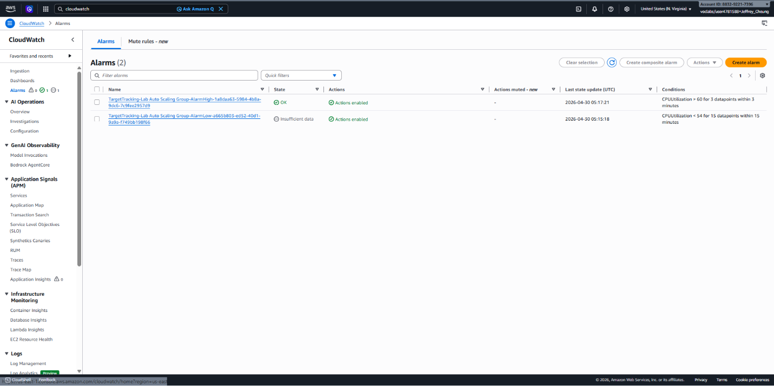
Generate Load
- Return to the web application.
- Select Load Test.
- Leave the page open so the load continues to run.
Monitor Scaling Activity
- Return to CloudWatch.
- Refresh the alarms periodically.
- Wait for:
  - AlarmHigh to change to In Alarm
  - CPU utilization to exceed the target threshold
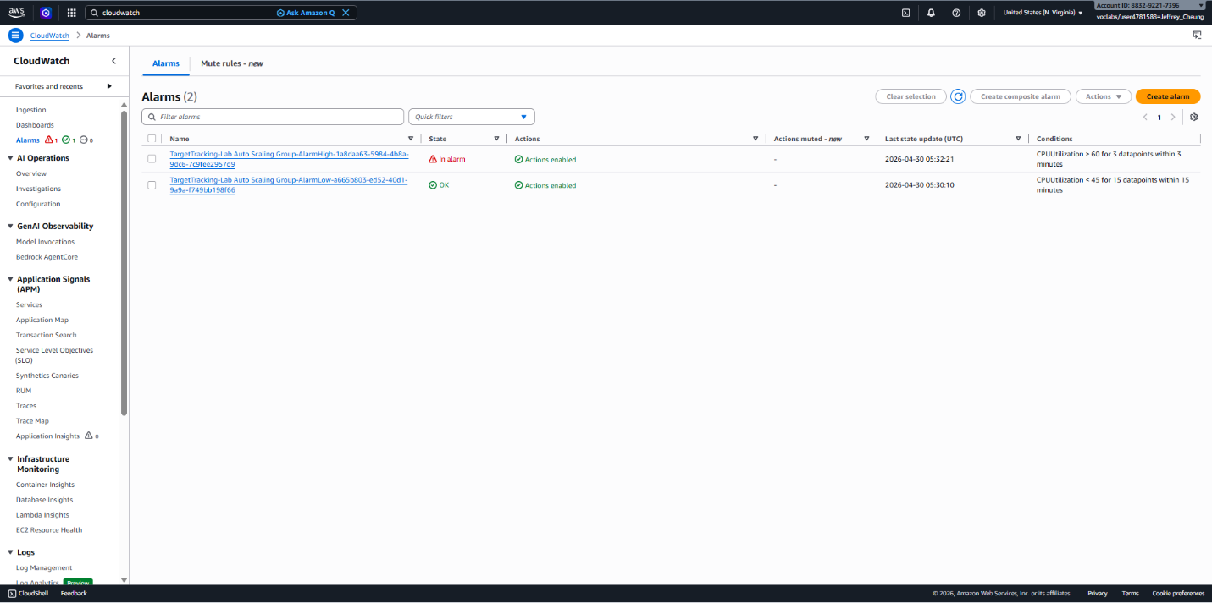
- Once the alarm is triggered, Auto Scaling launches additional instances automatically.
Verify New Instances
- Return to EC2 → Instances.
- Confirm that more than two Lab Instance servers are running.
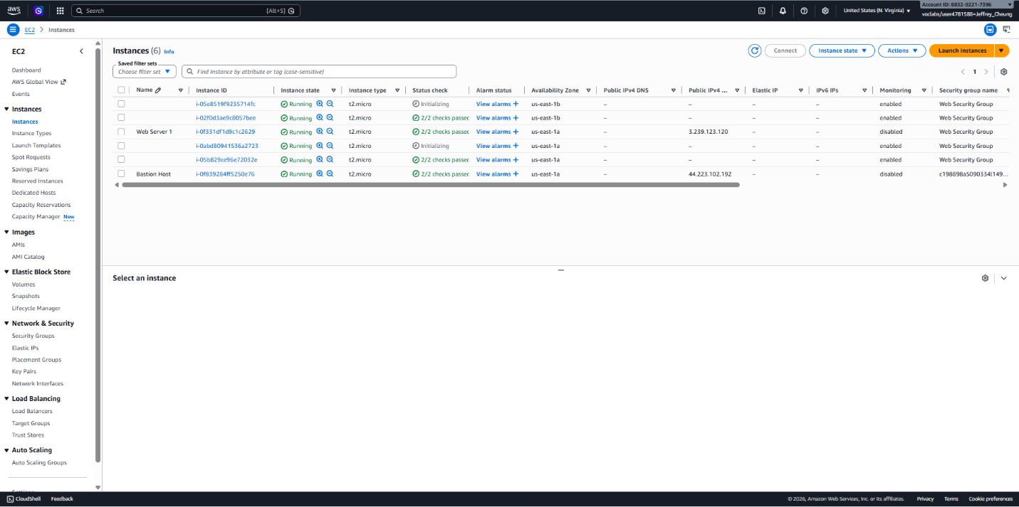
This demonstrates Auto Scaling responding automatically to increased demand.

Task 6: Terminate the Original Web Server
- Return to Instances.
- Select Web Server 1 only.
- Choose:
  - Instance State → Terminate Instance
- Confirm by selecting Terminate.
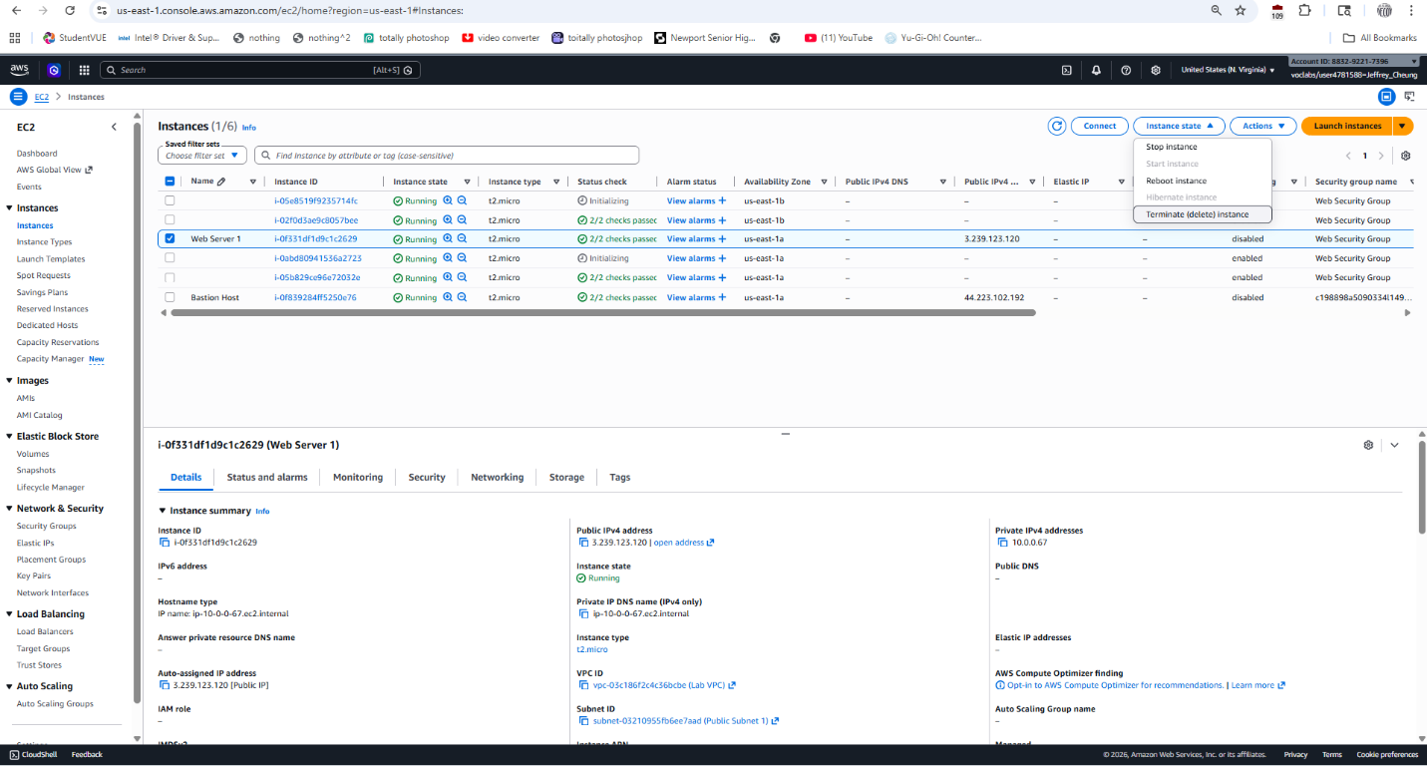
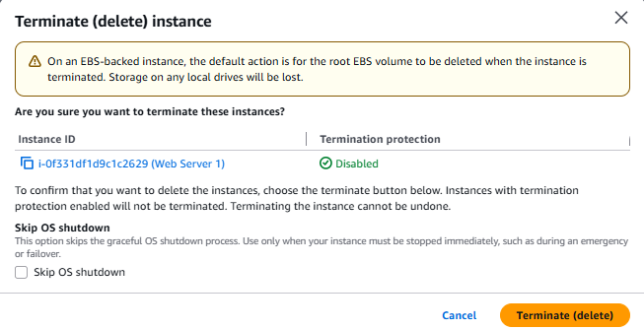
The original instance is no longer needed because its configuration has been captured in the AMI and is now managed through the Auto Scaling group.

Problems:
The AWS academy website was a big buggy and sometimes doesn’t detect you completing certain steps. Make sure as you do the lab to double check that it got checked off in the grades section. I had to redo several steps due to this issue and backtracking is pretty annoying to keep track of.
Conclusion
These labs were pretty good at applying concepts learned in the AWS lessons and it was interesting seeing how there’s a lot of automation that got implemented into AWS for better adaptability for companies.

